**DAILY ONLINE ACTIVITIES SUMMARY**

|  |  |  |  |  |  |  |  |  |
| --- | --- | --- | --- | --- | --- | --- | --- | --- |
| **Date:** | **5-06-2020** | | | | | **Name:** | **Javahar.S.Goutham** | |
| **Sem & Sec** | **7Th B sec** | | | | | **USN:** | **4AL16CS132** | |
| **Online Test Summary** | | | | | | | | |
| **Subject** | | **Big Data Analysis** | | | | | | |
| **Max. Marks** | | **30** | | **Score** | | | **13** | |
| **Certification Course Summary** | | | | | | | | |
| **Course** | **Introduction to ethical hacking (completed)**  **Rpa(completed)** | | | | | | | |
| **Certificate Provider** | | | **Great Learning**  **Guvi** | | **Duration** | | | **9hrs** |
| **Coding Challenges** | | | | | | | | |
| **Problem Statement**: 1. Write a Java program to implement Circular Linked List Using Array And Class.  **2.** Python program to square each odd number in the list. | | | | | | | | |
| **Status: YES, Completed all Programs.** | | | | | | | | |
| **Uploaded the report in Github** | | | | | **YES** | | | |
| **If yes Repository name** | | | | | https://github.com/alvas-education-foundation/Goutham-dotcom | | | |

Online Test Details: (Attach the snapshot and briefly write the report for the same)

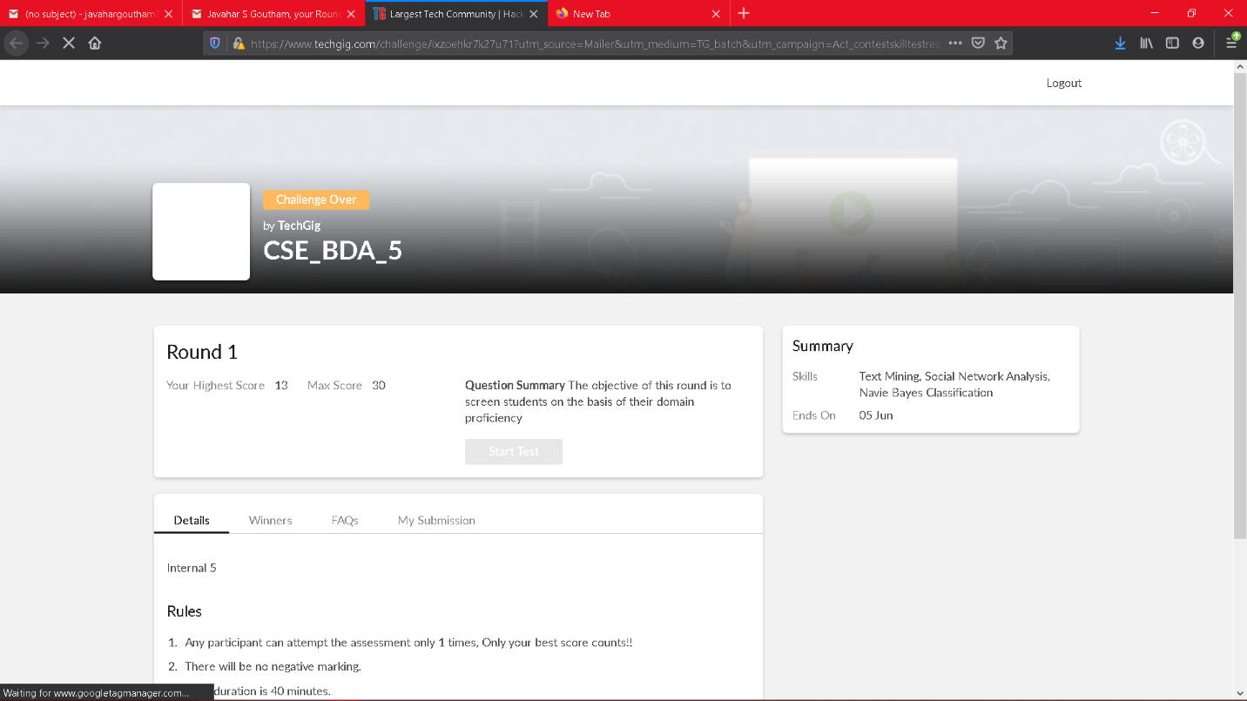

Scored 13 out of 30 in BDA test

Certification Course Details: (Attach the snapshot and briefly write the report for the same)

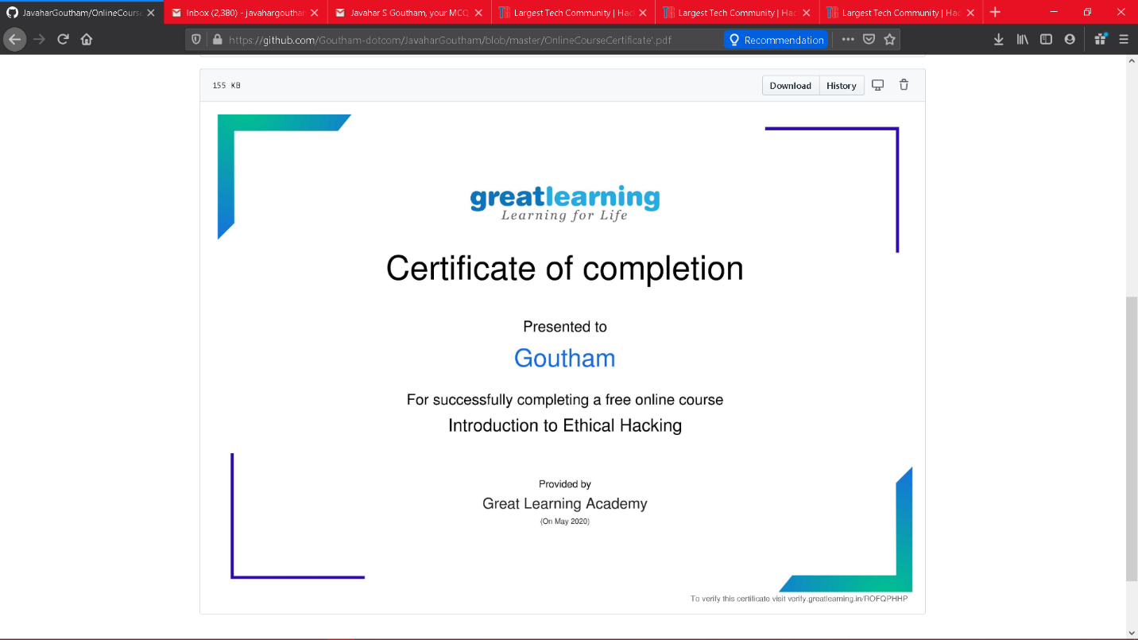

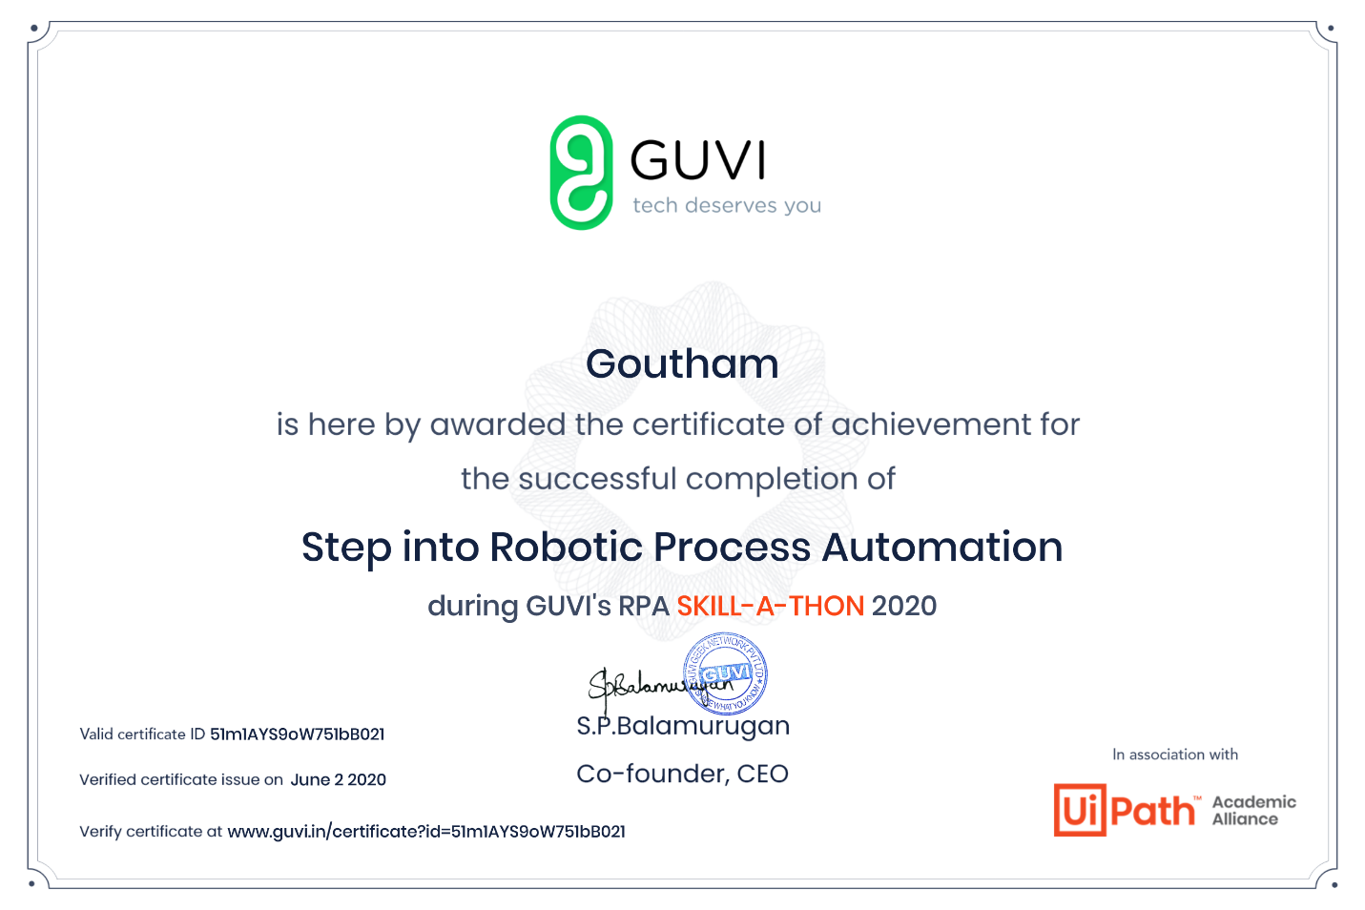

Coding Challenges Details: (Attach the snapshot and briefly write the report for the same)

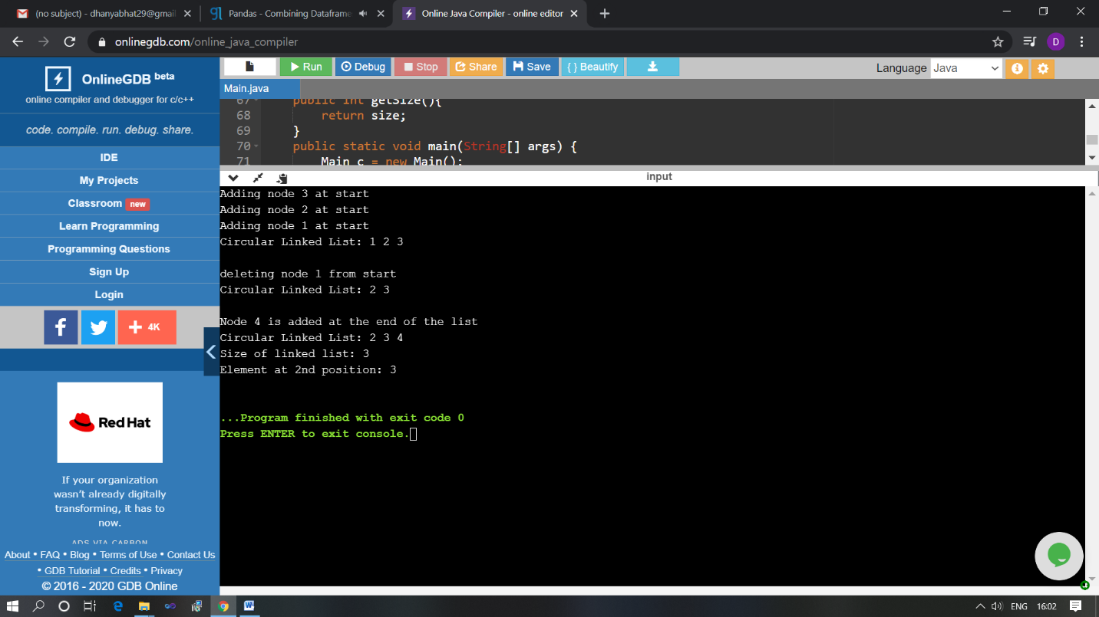

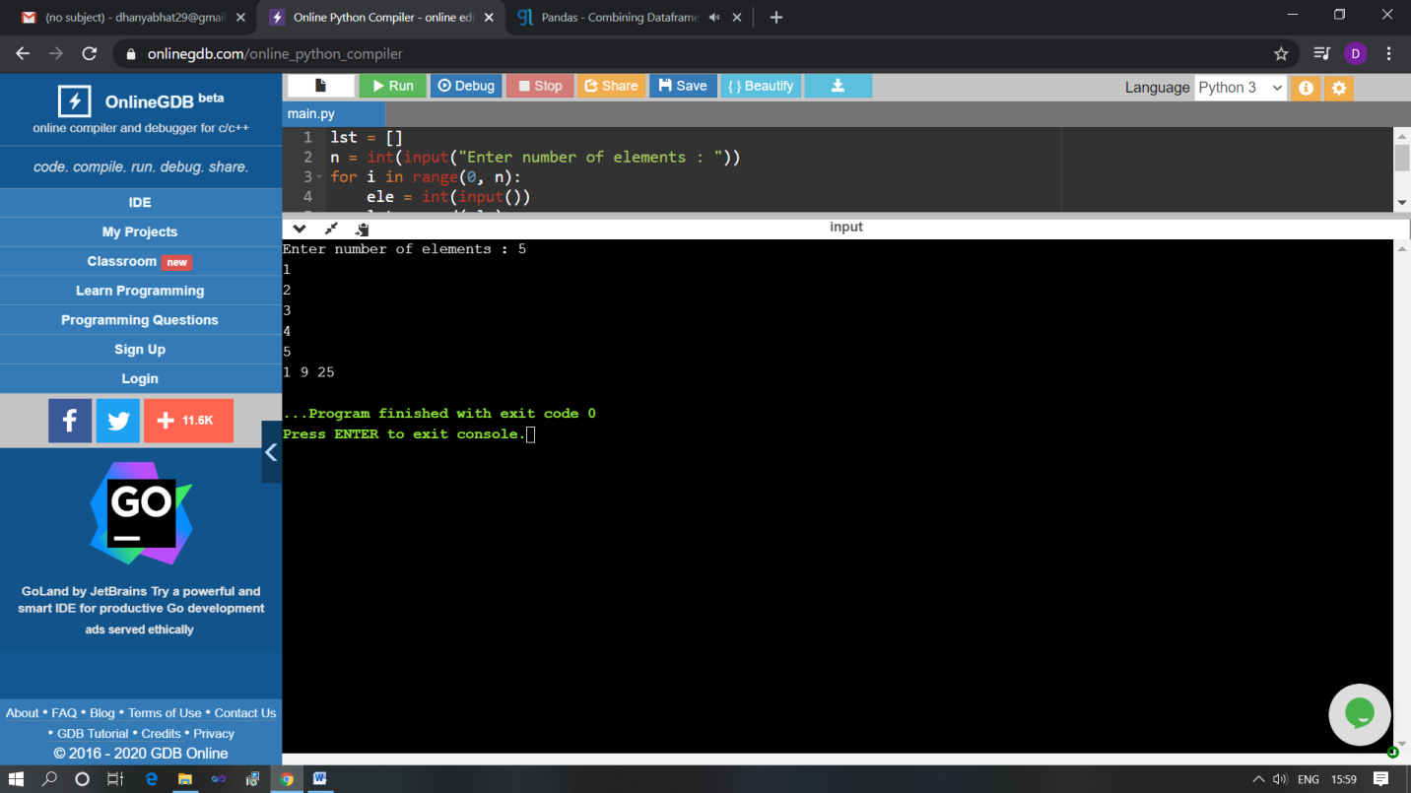The above Programs were written and executed and the output of the same is displayed above. The code for those 2 programs have been uploaded to the github repository and the link to the same is provided on the form.